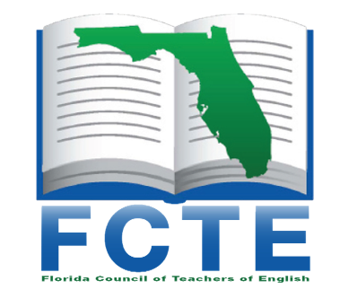
Florida Council of Teachers of English

Student Writing Awards

Guidelines for Teachers and Student Writers

Entry Form

- Any Florida teacher of English may sponsor a MAXIMUM of FIVE student nominees.

2. Any Florida student (grades 6-12) may submit up to three entries in up to three of the five categories:
(1) Poetry
(2) Fiction (1500 word max.)
(3) Script/Screenplay
(4) Personal Essay or memoir (1500 word max)
(5) Non-fiction/Other Essays (literary analysis, persuasion, journalism -1500 word max).

3. A single selection (one poem, one piece of fiction, one work of drama, or one work of non- fiction) constitutes an entry.

4. The student’s name, teacher’s name, and school name MUST NOT appear on any page of the entry. This information must be on the entry form ONLY. Title pages should NOT be submitted.

5. All entries must be submitted in electronic form and saved as the title of their piece and must be accompanied by a separate entry form. Please submit as an editable document, NOT PDF.

6. Term paper/research papers will NOT be accepted. Critical analyses which reference published works are acceptable.

7. Students or teachers must keep copies of entries, as they will not be returned to you.

If you have not completed these steps, the entry will automatically be DISQUALIFIED.

The entry form can be accessed online at www.fcte.org. Once completed, the entry form and the student work should be attached as TWO SEPARATE ATTACHMENTS.

Understand that in submitting the work, you are verifying that it is the authentic, original work of the student. You will receive an acknowledgement via email once your entry and entry form have been received and accepted.

Entries must be received by midnight on December 1 of each year. Winners receive a certificate of merit, recognition at the FCTE spring conference, a cash award, and copies of the Student Writing Anthology, Gulfstream.

Submit entries via email to: FCTEwritingawards@gmail.com Joanna Fox -Writing Awards Chair
FCTE Writing Awards Entry Form

- CONTACT INFORMATION

A. STUDENT INFORMATION
Name:
Street:
City/Zip:
Phone:

B. SCHOOL INFORMATION
Name:
County:
Street:
City/Zip:

C. TEACHER INFORMATION
Name:
Home Phone:
School Phone:
Email:

II. ENTRY INFORMATION
- DIVISIONS (Check the grade level the of the student when the piece was written.)

DIVISION I:
Grade 6 _____
Grade 7 _____

DIVISION II:
Grade 8 _____
Grade 9 _____

DIVISION III:
Grade 10 _____
Grade 11 _____
Grade 12 _____

B. CATEGORY (check one category and please note those with *1500-word limits):
1. Poetry ____
2. Fiction* ____
3. Script/Screenplay ____
4. Personal Essay/Memoir* _____
5. Non-fiction (analysis, journalism, essay)* _____

C. TITLE OF STUDENT WORK:
- VERIFICATION/ PERMISSION

Verification of Authenticity of Student Work and FCTE Right to Publish work in the manner described below:

In submitting this electronic entry, I certify that to the best of my knowledge this work is the original work of this student and that it is consistent with the quality of his/her other writing.
The student agrees that although he/she retains the rights to the material, he/she agrees that the Florida Council of Teachers of English may publish it in the FCTE Gulfstream or a special publication.

Teacher Name: ___________________________________________

Student Verification of Authenticity of the submitted work:
By participating in this process and submitting to FCTE, I understand that I am claiming to be the creator/author of this work and that it is my original writing.

Student Name: ____________________________________________

